

ContingencyPLAN

CHEMSEA

REACTION AGAINST CHEMICAL WARFARE THREATS: CONTINGENCY PLANS AND GUIDELINES

http://www.chemsea.eu

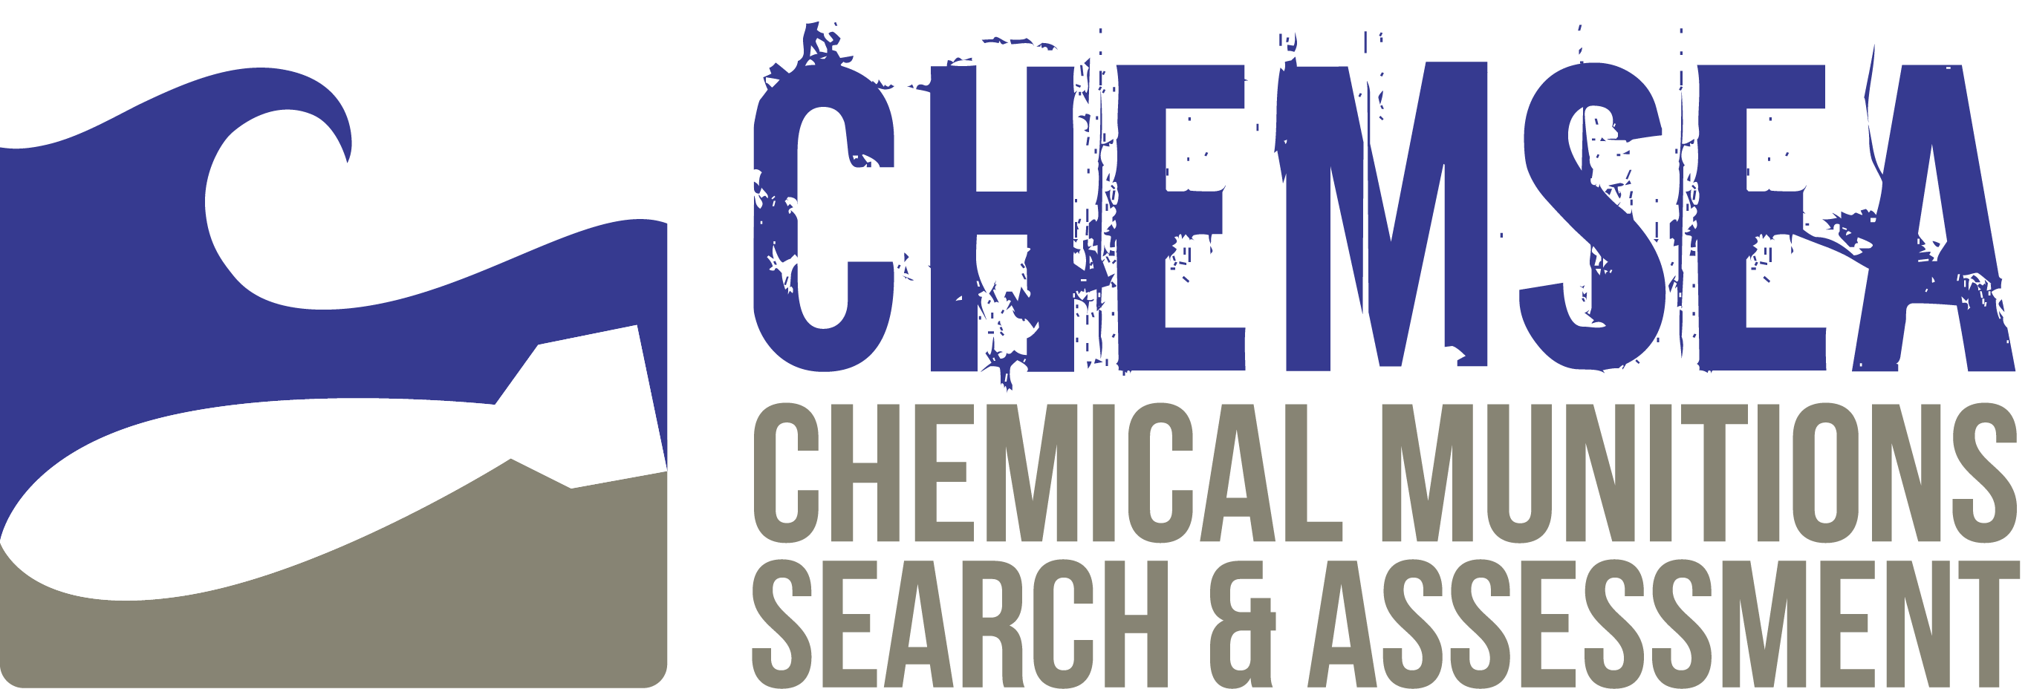

CONTENT

Unified models of contingency plans 3

The Sea Scenario 5

The Land Scenario 7

The Sea Scenario Model 8

The Land Scenario Model 9

Guidelines on CWA contamination at Sea 10

Unified models of contingency plans

The Baltic States, acting in accordance with the HELCOM CHEMU Report of 1995 and taking the safety of crewmen into account, have prepared instructions for fishermen to follow in the event of catching post war chemical munitions. However, nowadays such instructions seem too general and out-dated, leading to numerous difficulties in defining a EU-unified code of conduct that ship captains should follow in case of accidental catch of CW.

Moreover, the lack of regulations and knowledge concerning the responsibilities of national authorities in the area of decontamination procedures usually results in re-dumping of dangerous chemicals back into the sea, without reports to the appropriate authorities.

Therefore, one of the main goals of the CHEMSEA project was to develop a unified code of conduct in case of accidental catch of chemical munitions at sea or shoring on the beach, that may be implemented in all Baltic States, resulting in a unification of reaction procedures and national contingency plans.

The Research Framework

A framework of research was developed, being focused on current national contingency plans and national threat reaction models. The study included, but was not limited to, the following research questions:

1. Are national procedures in case of CW catching / shoring already in existence?

2. Are national bodies responsible for contingency planning already designated?

3. Is the contact information for such bodies well known and widely available?

4. How are CW treated in case of accidental catching / shoring?

5. Which body initiates the response operation in case of a CW related threat?

6. Are standard forms of CW related incident documentation available?

7. Are national decontamination procedures established?

8. Do national guidelines for crew men exist and are they up-to-date?

Fig. 1. The matrix of the national contingency plans analyses



THE RESEARCH RESULTS

The matrix of research results, depicted in Figure 1., allowed reaching the following main conclusions:

1. The Baltic States possess national services and agencies capable of taking action in order to minimise the threat posed by fished / shored CW, but their actions differ significantly.

2. The authority to be notified first in case of CW related accidents at sea would be the VTS / MRC (JRC) / MRCC (JRCC) officer – SAR Service in general.

3. Accident documentation, where available, is decentralised and incoherent.

4. Guidelines for fishermen exist in selected states but are out-dated.

5. Guidelines or routines (Standard Operating Procedures) for national contingency planning bodies are incoherent and require unification.

The research proved that current procedures and safety recommendations for accidentally or deliberately recovered CW munitions are regulated primarily by national legislation, taking HELCOM recommendations and guidelines into account. Common practice seems to be that accidentally recovered munitions are deliberately re-dumped, which does not comply with the Chemical Weapons Convention (OPCW 1997), but may be in particular the only way to ensure the safety of crewmen.

In order to get rid of identified discrepancies, CHEMSEA drafted, consulted and endorsed a unified process or model of reaction against the threat posed by accidently recovered or shored CW. The model was developed and introduced in the context of two generalised scenarios of contact with CW:

1. Chemical Warfare threat at sea – **The Sea Scenario**,

2. Chemical Warfare accident on the beach – **The Land Scenario**.

The Sea Scenario

The key elements of the sea scenario, depicted in The Sea Scenario Model, are:

• Ship at sea: endangered after accidental catch of suspicious items in the fishing or dredging gear;

• Search and rescue centre (SAR): initiates rescue operation after being notified about the accident and being called for assistance;

• Harbour master’s office: prepares and isolates the mooring pier in order to conduct the ship’s decontamination operation;

• Decontamination unit: conducts ship’s decontamination;

• Medical aid personnel: takes care of injured crewmembers brought to the harbour or evacuated from the vessel at sea.

Vessel crewmembers should be alert for the following signs that a chemical munition or chemical agents are present on-board:

• Unusual odour from equipment or fish;

• Stinging sensations in the eyes;

• Burning or irritated skin;

• Presence of an oily liquid;

• Corroded containers or suspicious clay-like lumps.

In the case of catch or extraction of such a substances the ship’s captain is obliged to take every possible precautionary measure to remove the dangerous substances from the vessel (Note: If a munition is encountered while in harbour, the land scenario should be initiated). When the dangerous substances have been removed from the vessel the captain should:

• Note the position of removal (re-dumping) of dangerous materials;

• If possible, mark the position with a buoy of yellow colour.

Afterwards, the SAR Centre should be immediately notified and provided the following information:

• The vessel’s position (use World Geodetic System 1984 [WGS-84] for reporting). If the exact position is unknown, approximate coordinates should be given or a range and bearing from a charted feature;

• The activity (e.g. fishing, clamming, dredging) being conducted when the munition was encountered;

• A general description of the munition’s key features (e.g. size, shape, fins, markings) and overall condition, if observed or known;

• Any unusual odours;

• The actions taken (e.g., secured munition on deck, munition carefully returned to the water, washed off deck where munition was retrieved to protect the crew).

The ship’s captain should maintain a radio watch in order to be provided with further instructions and should strictly follow any instructions received. Particularly, vessels that may have come in contact with chemical agents should not bring their catch ashore, unless instructed to do so. Prior to entering the harbour, the appropriate harbour master’s office should indicate a mooring pier, located as far as possible from other vessels already moored in the harbour. It is forbidden to unload or get any materials off the vessel before the decontamination unit arrives to inspect and decontaminate the vessel.

The Business Process Management software

Both the Sea and Land Scenario Models, depicted in this report, have been prepared with utilization of the Business Process Management (BPM) software - **bizagi Modeler**.

The source files of both models are available to download at the CHEMSEA project webpage, while the **bizagi Modeler** software, required to view the models, is available to download freeware, at the manufacturer’s website:

<http://www.bizagi.com/en/bpm-suite/bpm-products/modeler>

The Land Scenario

The key elements of the land scenario, depicted in The Land Scenario Model, are as follows:

• Potential finder: usually unaware of possible threat connected with suspicious object washed ashore;

• Crisis management centre: represents the local emergency services called by a finder requesting assistance;

• Police / fire departments: take in situ actions to isolate and secure the area of the finding;

• Decontamination unit: conducts decontamination of people and finding;

• Medical aid personnel: provides medical assistance to the injured or burned.

Similarly to the sea scenario, the finder should be alert for the following signs that a chemical munition or chemical agents are present in the object washed ashore:

• Unusual odour of the object found;

• Stinging sensations in the eyes;

• Burning or irritated skin;

• Presence of an oily liquid;

• Corroded containers or suspicious clay-like lumps.

In case of finding a suspicious object ashore, it is strictly forbidden to approach, move, dismantle or touch the object. Additionally, a safe distance should be kept at all times. Notification of the finding should be directed to the nearest police or fire department station or emergency response centre.

Having received a notification concerning a CW related accident ashore, the emergency response centre forwards the notification to local police stations, rescue departments (fire departments) and medical ambulance services. Resources and manpower are sent to the scene of the accident in order to secure the area and transport routes (police), diagnose the accident scene (rescue / fire department) and provide medical assistance (medical ambulance).

If initial diagnosis of the accident scene confirms the presence of CWA, a specialised decontamination unit is called in to conduct the decontamination, remedy the consequences of contamination and restore the environment to an appropriate state.

The above general models of reaction against threats posed by accidently recovered or shored CW were compared with national contingency plans in order to reveal strengths and weaknesses of state specific solutions.

As a result, CHEMSEA encouraged national authorities of Baltic States to introduce improvements to their current procedures.

The Sea Scenario Model

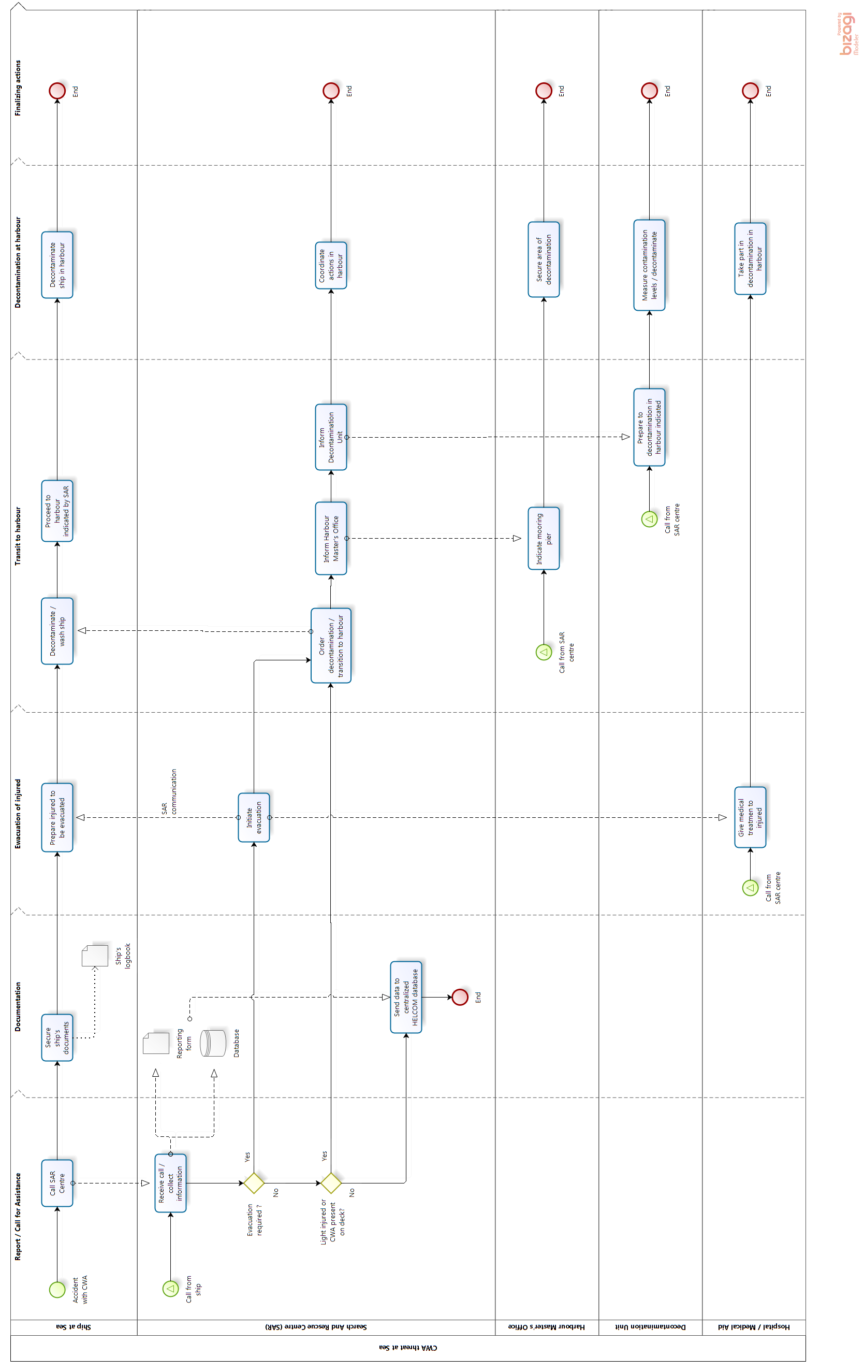

The Land Scenario Model

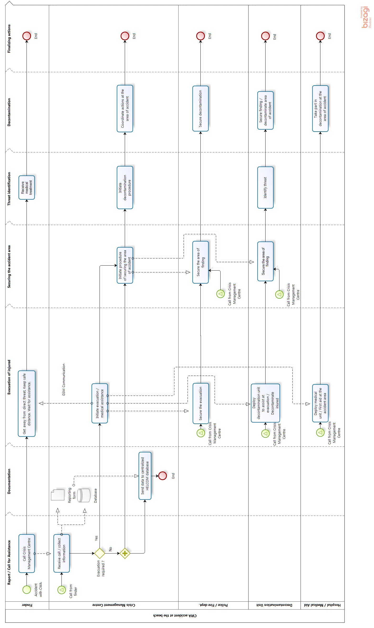

Guidelines on CWA contamination at Sea

As far as any type of munitions present a potential explosive or chemical agent hazard, they should not be moved, disturbed or handled. However, at sea and depending on the circumstances, precautionary actions may be required to protect the vessel and crew members.

Therefore, in case of catch or extraction of hazardous or noxious substances of military origin, particularly CWA, the following actions should be taken:

• Do not touch neither caught or extracted materials nor the fishing equipment or potentially contaminated parts of the vessel

• Keep contaminated parts of the vessel leeward, if possible

• Close hatches and windows of the wheelhouse and compartments

• Collect the clothing of crew members who came into contact with contaminants in the foil sacks and tighten them firmly

• Report the accident to the SAR officer / Harbour master, providing the following information:

• What, where, when and by whom has been caught or extracted

• Crewmembers who may have been contaminated or injured

• Keep a radio watch in order to be provided with further instructions

• Follow instructions given by the SAR officer / Harbour master,

• If ordered, steer the vessel to the forefront of the nearest harbour

When a munition is recovered by the fishing gear but not brought on-board:

• Stop all fishing operations immediately

• Do not try to bring the munition or gear containing the suspected object / contaminant on-board

• Do not allow the munition to come or remain alongside the vessel, where sea waves could cause the munition to contact the hull

• Lower the fishing gear carefully back into the water, note its position and report it to the SAR officer / Harbour master,

• If possible, mark the position with a yellow buoy

• Await assistance and follow further instructions, as ordered by the SAR officer / Harbour master.

When the munition has been brought on-board:

• Immediately secure the munition to prevent its movement

• Keep the crew upwind and away from the munition / contaminant

• Minimise handling and decide whether it is safest to return the contaminant to the water or retain it on-board.

When the munition remains on-board:

• Keep the crew upwind and away from the munition / contaminant

• Minimise handling and avoid disturbing any part of the munition

• Secure the munition on deck to prevent its movement; do this as far away as possible from heat sources, vibrations and crew members

• Cover the munition with wet blankets or wet cloths to reduce the potential for deterioration of metal parts and release of its contents and to reduce the risk of explosives drying up and becoming more sensitive to shock

• Immediately contact the SAR officer / Harbour master for assistance

• Await assistance and follow further instructions as ordered by the SAR officer / Harbour master

If, despite precautionary actions taken, any crew member comes into contact with CWA:

• Immediately remove any lumps or drops of toxic substance from the skin using the back side of a knife or similar object, clean pieces of fabric, etc.

• Carefully wash the contaminated skin with fresh water mixed with soap

• After drying, decontaminate the skin using the decontamination package (if available)

• Do not perforate the blisters on the skin – they keep the body from further penetration by the chemical agents

• Report the accident to a SAR officer / Harbour master and request assistance

• Place contaminated crew members in a separate compartment or on a windward deck and wait for professional assistance, as ordered by the SAR Officer / Harbour master

In case of eye irritation:

• Never rub the eyes, even if they sting

• Wash the eyes with large amounts of fresh water, in the direction from the nose toward the external corners

• After washing, close the eyelids and wash the skin around the eyeballs with freshwater mixed with soap

• Do not use any ointments, do not bandage the eyes

Visible skin symptoms of CWA contamination may not appear immediately, only following hours or days.

Therefore, in every single case when the crew member observes a suspicious object in the fishing gear or an unusual smell in the caught fishes or the fishing gear itself resulting in stinging of the eyes or throat, it should be assumed that the vessel might have been contaminated with chemical munitions and all the precautionary actions, described above should be taken.